INTERNET GATEWAY AND ROUTE TABLE

Internet Gateway :

An internet gateway is a virtual router or networking component that allows a network to communicate with the public internet. It translates private IP addresses from a local or cloud network into public, internet-routable IP addresses.

Route Table :

A route table is a set of rules, or routes, that tells a router where to direct network traffic.

Example Scenario :

Let us setup web server with a public subnet and a database server with a private subnet in AWS, including an internet gateway and route tables.

VPC

PUBLIC SUBNET PRIVATE SUBNET

DB SERVER

WEB SERVER

IGW

1. Let us create VPC :

* Go to <https://aws.amazon.com>.
* 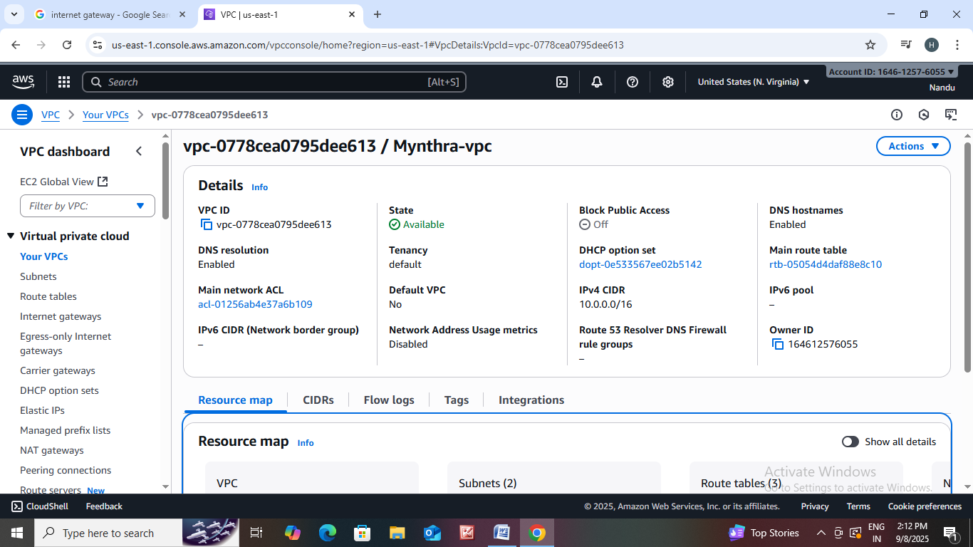 Sign into console home navigate to VPC.
* Click on create VPC.
* Resources to create : VPC and more
* Name : Mynthra
* Ipv4 CIDR block : 10.0.0.0/16
* No of availability zones :1
* No of private subnets : 1
* No of public subnets : 1
* NAT Gateway : None
* VPC endpoints : None
* Create VPC

1. Let us Create EC2 Instance.

WEB SERVER

* Go to console home then search for EC2 instance in search bar.
* Click on launch instance.
* Name : web server
* AMI : ubuntu 22.04 LTS (HVM),SSD volume type
* Instance type : t3.micro
* Create new key pair : webserver key
* Edit the network settings.
* Select your public subnet and enable IP.
* Then click on launch instance.

DB SERVER

* Go to console home then search for EC2 instance in search bar.
* Click on launch instance.
* Name : db server
* AMI : ubuntu 22.04 LTS (HVM),SSD volume type
* Instance type : t3.micro
* Create new key pair : dbserverkey
* Edit the network settings.
* Select your private subnet and enable IP.
* Then click on launch instance.

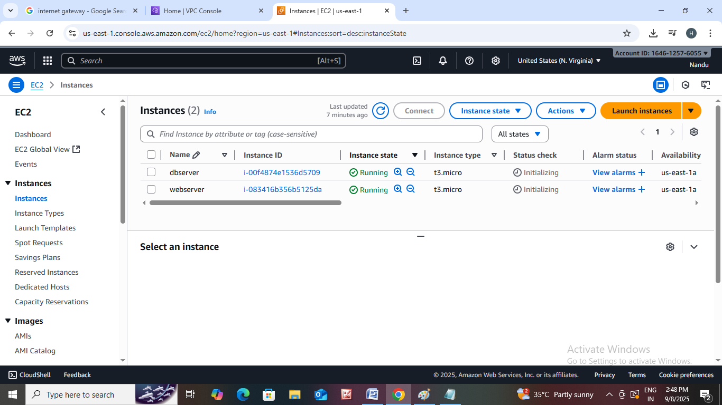

* Go to internet gateway.
* You can detach our correct mynthra IGW to mynthra vpc.
* We can create another one .
* We can attach your IGW to VPC by click on action option.
* Open Route table we can edit subnet associations and routes.

